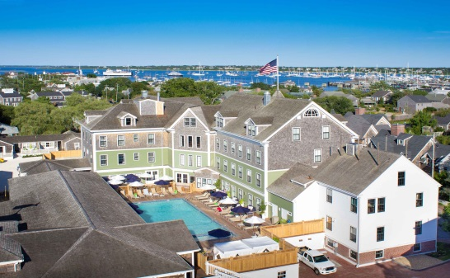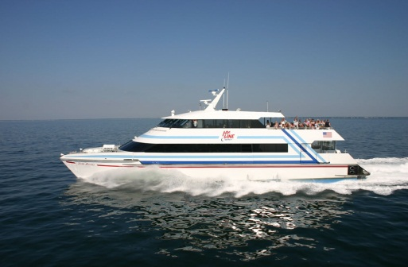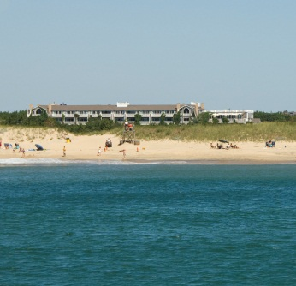

Explore Nantucket & Martha’s Vineyard Together on Your Vacation…Two-Island Vacation Adventure!
Option 2 - Nantucket First, Martha’s Vineyard Second*
(Passenger-only; leave your car on the Mainland in Hyannis)

Available May 24 - October 14, 2019 - Daily Departures via Ferry

- Hyannis to Nantucket; Nantucket to Martha’s Vineyard; Martha’s Vineyard to Hyannis
Leave Hyannis Arrive Nantucket Ferry Name
May 24 to Oct. 14 – 2:25pm | May 24 to Oct. 14 – 3:25pm | Hy-Line Fast Ferry
*Includes transfers to The Nantucket Hotel & Resort. You must stay a minimum of two nights at the Hotel
Leave Nantucket Arrive Martha’s Vineyard Ferry Name
May 24 to October 14 – 10:30am | May 24 to October 14 – 11:40am | Hy-Line Inter-Island Ferry
*Includes transfers to the Winnetu Oceanside Resort. You must stay a minimum of two nights at the Resort
Leave Martha’s Vineyard Arrive Hyannis Ferry Name
May 24 to Oct. 14 – 10:20am | May 24 to Oct. 14 – 11:20am | Hy-Line Fast Ferry

April 19 – May 23 & October 15-27, 2019 – Daily Departures via Cape Air
For guests choosing to travel between the island during these time periods, the inter-island service is available through Cape Air, 800-CAPE AIR and can be booked independently by the guest. Hy-Line fast ferry service operates between Hyannis and Martha’s Vineyard and Hyannis and Nantucket. We are happy to make arrangements for ferry travel and associated transfers for you.
Pricing includes all passenger ferry transportation and transfers to-and-from the hotels. Accommodation charges are additional.
2019 Price Adults: $120.00 | 2019 Price Children (ages 5-12 years): $80.00 | Children (ages 4 years and under): Free; but reservation still needed for trip eligibility

